Muon Fitting Widgets

Design & Implementation

# Introduction:

This document outlines the design and implementation of the fitting widgets used within the Muon Analysis and Frequency Domain Analysis GUIs. These widgets have been created with the aim that they are reusable across many parts of the Muon fitting framework.

# The Different Fitting Widgets:

There are currently three different fitting widgets used in Muon fitting, each written in an MVP style:

1. The *Basic Fitting Widget* is the most basic of the fitting widgets. It allows you to perform a fit, undo a fit, plot a guess, and open the Fit Script Generator. The fit can be a single or double pulse fit. It also provides the ability to choose fit functions and other fit options.
2. The *General Fitting Widget* has all the capabilities of the *Basic Fitting Widget*, plus it allows you to perform simultaneous fits over specific Runs and Group/Pairs. It also allows you to cycle through the different datasets which are loaded into the fitting widget.
3. The *TF Asymmetry Fitting Widget* has all the capabilities of the *General Fitting Widget*, plus it has a TF Asymmetry fitting mode where you can enter a normalisation parameter and perform a TF Asymmetry fit.

# Where is each widget used?

This section describes where the widgets are used, and how they are each separated into sub-widgets. This separation allows the order of the sub-widgets to be changed so that all the widgets comprising the *Basic Fitting Widget* (for example) do not have to be next to each other. Instead, each sub-widget is added to specific area within a vertical layout as illustrated by this image.

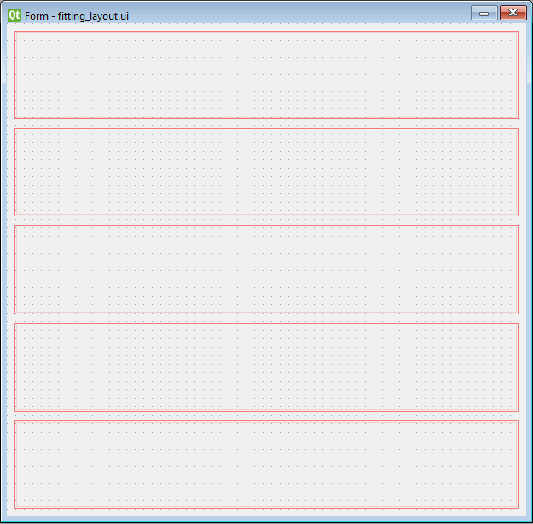

General Fitting Options

TF Asymmetry Normalisation

TF Asymmetry Mode Switcher

Fit Function Options

Fit Controls

## Basic Fitting Widget

The *Basic Fitting Widget* is not used on its own in any of the Muon interfaces, instead it acts as an initial ‘building block’ for the other fitting widgets. It consists of two separate widgets, the *Fit Controls* widget, and the *Fit Function Options* widget.

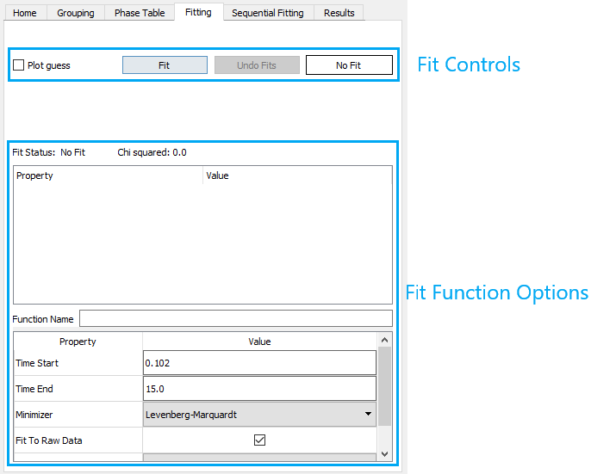

The following diagram details the file organisation for the *Basic Fitting Widget*. The Fit Controls widget and Fit Function Options widget is added to the fitting layout within the constructor of the Basic Fitting View. The dotted arrow means ‘*has a’* and the full arrow means ‘*is a*’ (i.e. inherits from).

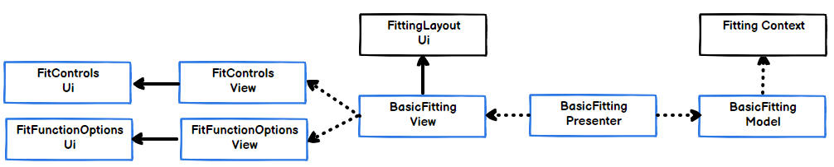

## General Fitting Widget

The *General Fitting Widget* is used on the fitting tab of Frequency Domain Analysis. It inherits the widgets found in the *Basic Fitting Widget*, and it also has a *General Fitting Options* widget which allows you to perform simultaneous fits over specific Runs and Group/Pairs.

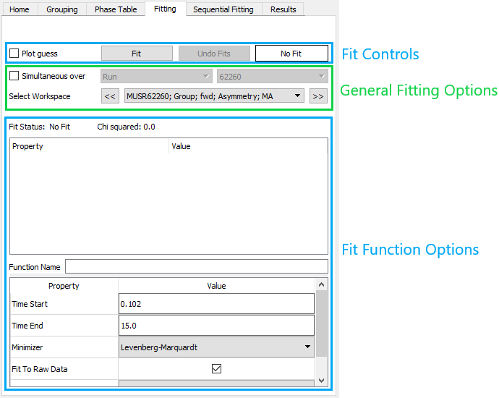

The following diagram details the file organisation for the *General Fitting Widget*. The General Fitting Options widget is added to the fitting layout within the constructor of the General Fitting View. The dotted arrow means ‘*has a’* and the full arrow means ‘*is a*’ (i.e. inherits from).

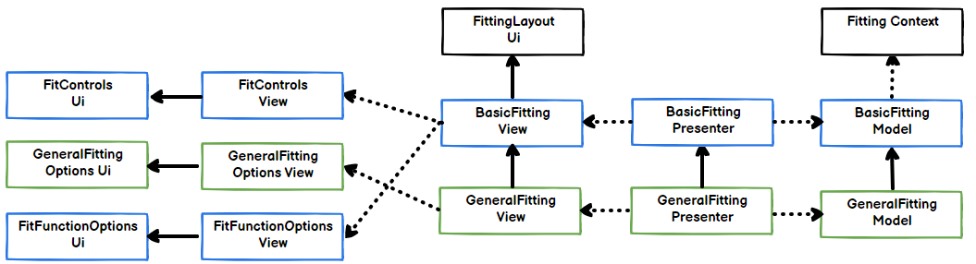

## TF Asymmetry Fitting Widget

The *TF Asymmetry Fitting Widget* is used on the fitting tab of Muon Analysis. It inherits the widgets found in the *General Fitting Widget*, and it also has a *TFA Asymmetry Mode Switcher* widget and a *TF Asymmetry Fitting Options* widget which allows you to perform a TF Asymmetry fit with a normalisation.

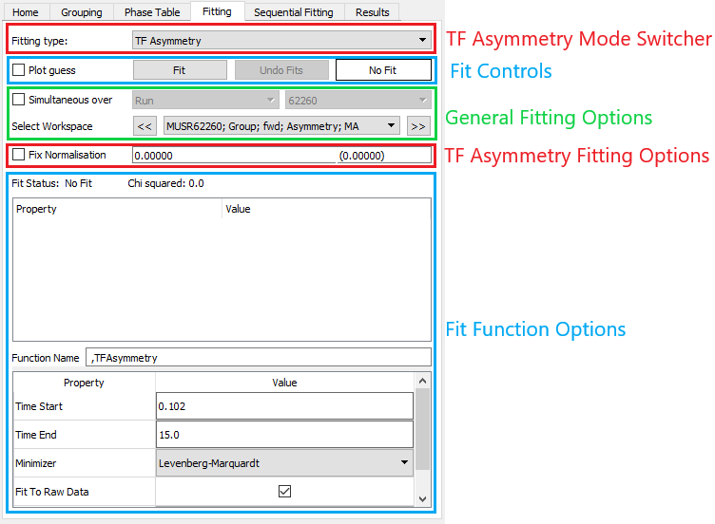

The following diagram details the file organisation for the *TF Asymmetry Fitting Widget*. The TF Asymmetry Fitting Options widget is added to the fitting layout within the constructor of the TF Asymmetry Fitting View. The dotted arrow means ‘*has a’* and the full arrow means ‘*is a*’ (i.e. inherits from).

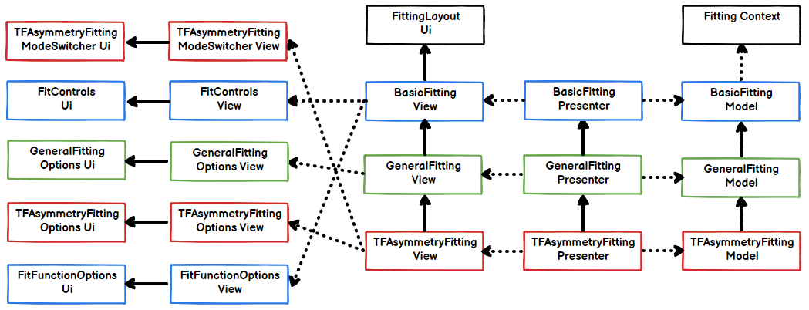

# Notes

If any further changes are made to the design or organisation of these widgets then this design doc should be updated.